**1、backend**



Enter **python manage.py runserver** in the terminal to start the backend program files.



**2、frontend**

Enter **npm run serve** in the terminal to start the frontend program files.

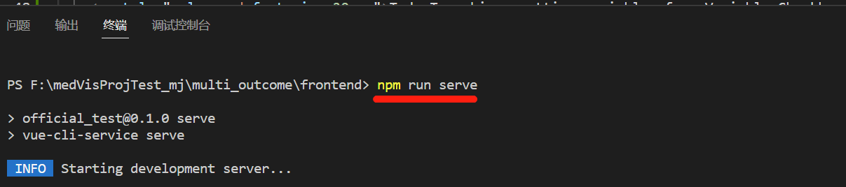

**3、Operation interface**

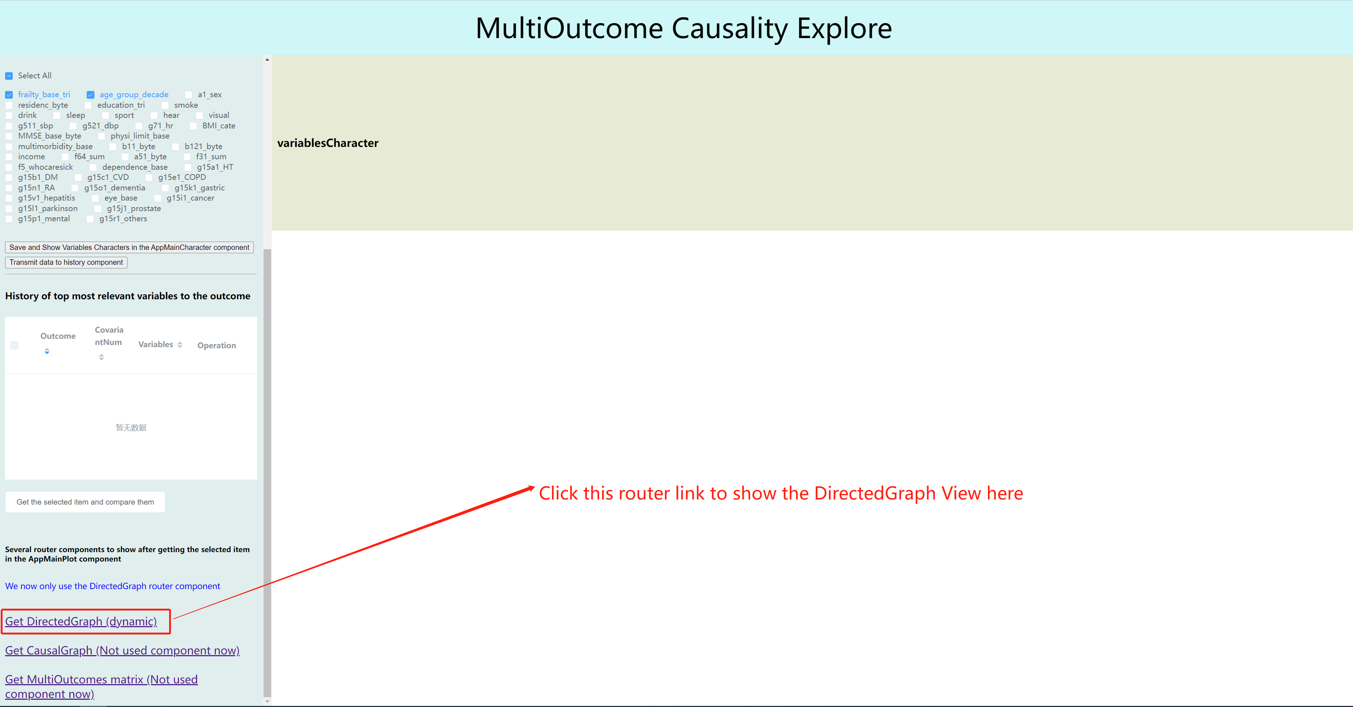

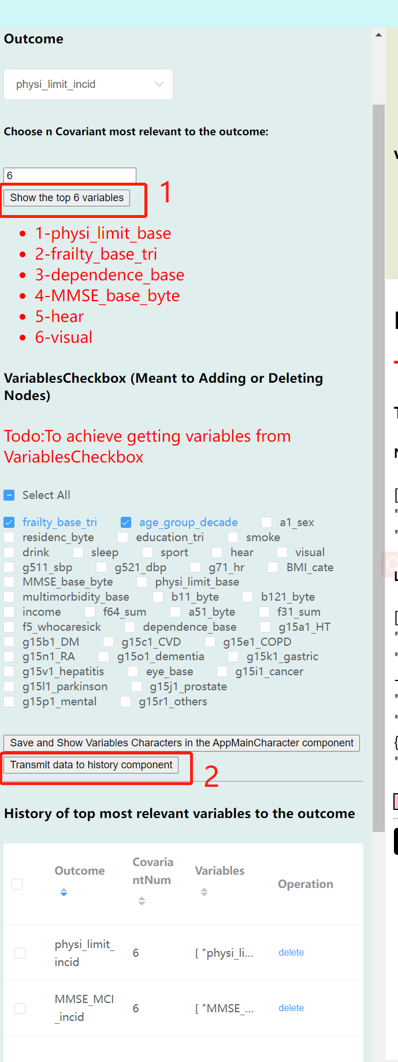 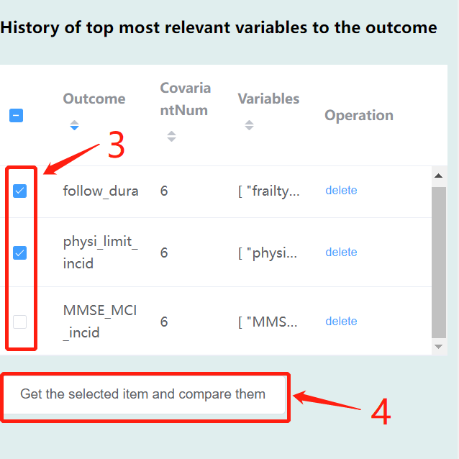

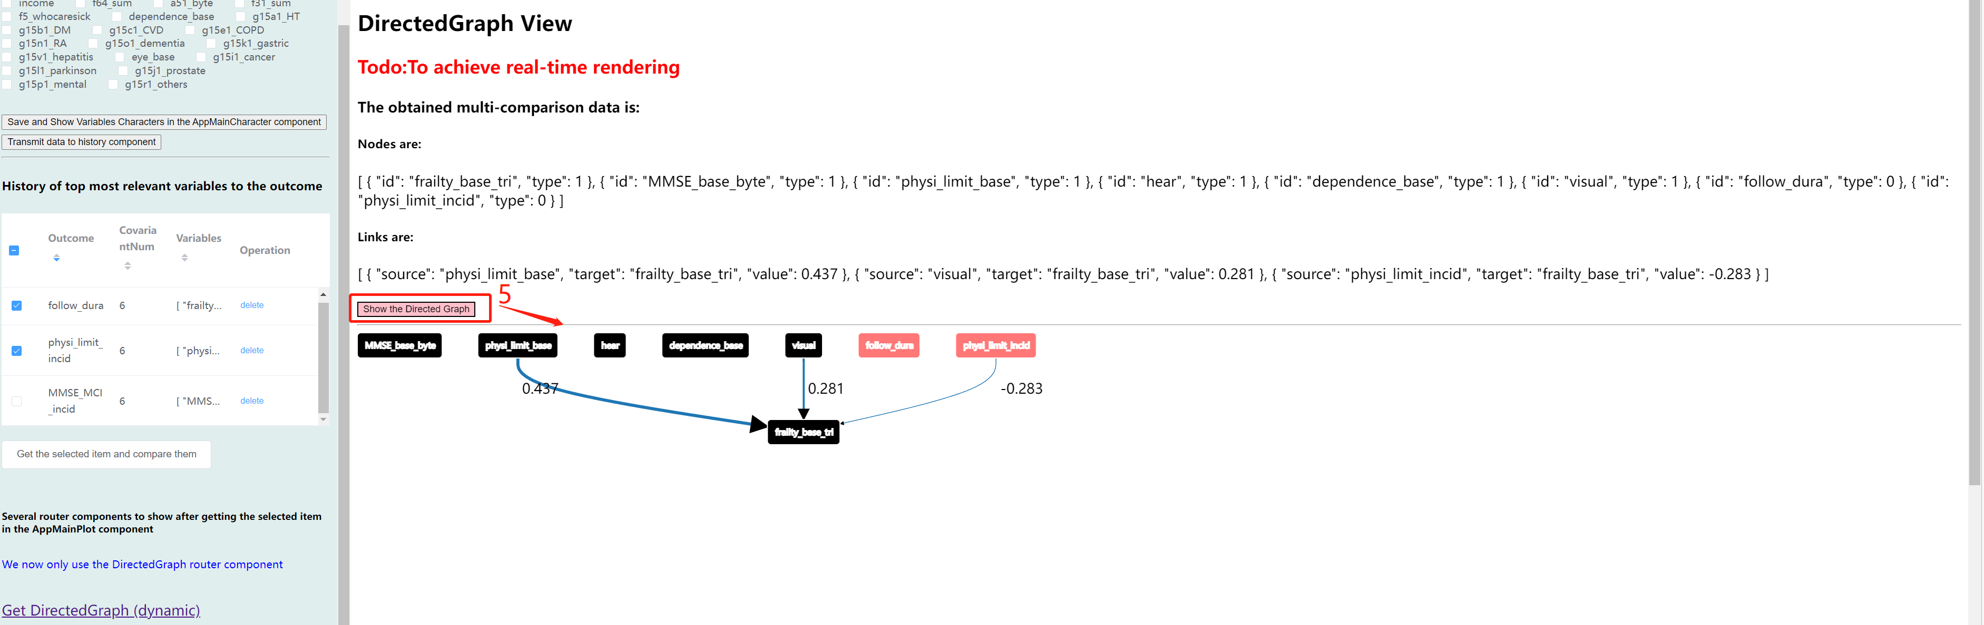

1、After selecting the outcome variable and the number of variables, click show... Button to get data from the backend.

2、After obtaining the data from step 1 above, pass the calculated data to the history component below.

3、Select the items you want to compare.

4、Click the button to obtain the final distinct nodes and links.

5、Click the button to show the updated graph.